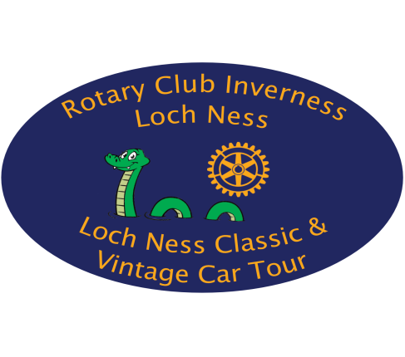

-ROTARY CLUB OF INVERNESS LOCH NESS CLASSIC & VINTAGE CAR TOUR -
- Saturday 8th June 2024 -
REGULATIONS
- Announcement:-
The Rotary Club of Inverness Loch Ness Classic & Vintage Car Tour will be run on Saturday 8th June 2024. The event will start from the Inverness Ice Centre, Bught Drive, Inverness (OS Map Reference 28/658437). A map of the event assembly area/signing on, event start and finish locations will be issued with the Final Instructions.
- Vehicle Eligibility:-
All Vintage, Historic and Classic cars (including more modern cars of a sporting nature) and also Vintage & Classic Motor Cycles are welcome. Entries are limited to a maximum of 65 vehicles.

- Entries:-
The Entry List opens on publication of these Regulations and Entry Form and will close finally on 31st May 2024 or, A} at the organisers discretion or B} when the maximum entry of 65 cars is received,. Entries received after Entry List is full or after closing date (whichever is soonest) will be placed on the Reserve list.
There is NO ENTRY FEE for this event as it is intended to be a day of fun and fellowship among like-minded classic vehicle enthusiasts, however all entrants are requested to raise at least £100 SPONSORSHIP from family, friends and business colleagues 2/3rds of which will be distributed, for the 2024 Tour between the principal charities CHAS-Children’s Hospices Across Scotland (registered Scottish Charity number SC019724) and Highlands and Islands Blood Bikes (registered Scottish Charity number SC049345) and the remainder to charities (local, national and international) supported by the Rotary Club of Inverness Loch Ness who are organisers of the Tour.
All donations received will go to the Rotary Club of Inverness Loch Ness Trust Fund (Scottish Charity No:- 040568) for distribution to, as stated above, the principal charities CHAS-Children’s Hospices Across Scotland (registered Scottish Charity number SC019724) and Highlands and Islands Blood Bikes (registered Scottish Charity number SC049345) and other local, national and international deserving causes which the Fund supports. In addition, donations can be increased by 25% if your sponsor(s) is/are taxpayers and tick the Gift Aid Box when completing the Sponsorship Form. Please note that the sponsors must include their home postcode as a minimum for this to be effective. NB - Cheques from registered Companies are not eligible for Gift Aid.
The Sponsorship Form together with the Monies collected can be mailed in advance, handed in on the day, or sent, no later than seven (7) days after the event to Mr N Manson, 23, Island Bank Road, Inverness, IV2 4QS. Cheques to be made payable to Rotary Club of Loch Ness.

- What is included:-
Rally Plate for each car
Road / Map Book
5. Route Navigation and Driving Behaviour:-
The route will be on public A and B class roads and unclassified roads some of which may be single track. You should be aware that some of the roads may be uneven and care should be exercised on low slung vehicles. A Road / Map Book will be provided – Navigation will be by “ball & arrow” rally instructions (you travel from the “ball” to the “arrow”) and these will include total and interim mileages and the instructions will be complemented by relevant marked maps of the route. An explanatory page on the route instructions will be included in the Road/Map Book and also sent out with the Final Instructions so that co-drivers may acquaint themselves with the information.
Please be aware of other road users, cyclists, walkers and livestock, particularly on single track roads. Please do not hold up following traffic and avoid driving in groups – leave sufficient room between vehicles for other traffic to overtake, or pull into a convenient lay-by. On single track roads, if you are holding up another car, be it a participant on the Tour or otherwise, please pull into the first available passing place but do not use these passing places as rest / viewing stops.
Participants must at all times comply with the requirements of the Road Traffic Act and drive in a responsible and considerate manner making due allowance for weather and road conditions.
In the event of a traffic accident / incident, drivers are to follow normal reporting procedures.

- Route for 2024
The route for the 2024 Tour will take in roads in the Loch Ness area, around the A9 corridor and Morayshire before returning to the Inverness finish.
7. Qualification / Licences:-
There is no element of competition on this event (i.e., there are no timed sections whatsoever) so no special qualifications are required. However, a full valid Driving Licence is required.

8. Insurance:-
Insurance is solely the responsibility of the driver. Normally no special insurance is required for a Classic Car Tour, however, you are advised to check with your insurance provider whether you will be covered for this type of event. A minimum of Third Party Insurance for all persons who will drive participating vehicles must be applicable for the duration of the event

9. Scrutineering / Signing On:-
The car must have available for inspection an MOT certificate (if applicable) and a Certificate of Insurance. The Driver will be required to sign a declaration confirming that the car is insured and both Driver and Passenger(s) will be required to sign a Declaration indemnifying the Organisers from liability on the Signing-On Sheet at the start of the Tour.

-o0o-

